TMT/A To Z CNC Engineering /S0508/2025 18 -10- 2025

To,
Syed Zeeshan

A To Z CNC Engineering
Click to call: +91-6302354607
Email: atoz.cncengineering@gmail.com
Plot No 98 Survey No 374, Quthbullapur Mandal,
Ida Kukatpally, Kukatpally, Gandhi Nagar,
Hyderabad - 500037, Telangana, India

Dear sir,

Sub :- Supply of COMPLETE CNC PRESS BRAKE MACHINE. 2000x4

We are very much thankful to you for your kind conversation extended to us for detailed discussions in regard to the manufacturing of machinery that are required by you. As requested by you we are submitting hereunder the detailed specifications in item wise together with the make of standard peripherals that are connected to the respective machinery.

CNC HYDRAULIC PRESS BRAKE MACHINES ARE DESIGNED TO ACHIEVE FASTER PRODUCTION, PRECISION BENDING WITH MINIMUM MAINTENANCE AND SAFETY. THIS IS ACHIEVED BY THE FOLLOWING POINTS:
HIGHLITES OF THE MACHINE
MINIMSED PIPING ELMININATING PIPE BREAKAGES AND RAMS FAILLING.
- CLOSE LOOP HYDRAULIC SYSTEMS DESIGNED TO ACHIEVE AND MAINTAIN DESIRED BENDING OPERATION.
  - ReduceS errors by automatically adjusting the systems input.
  - enhanceS robustness against external disturbances to the process.
  - produceS a reliable and repeatable performance.
- stress relieving allows syMMetrical machining of the frame resulting to acute tolerances.
- heavy and rigid construction minimising deflection in the frame while bending.
- modular design eases replacing worn out parts when necessary.
- SERVO PROPORTIONAL PRESSURE CONTROL SYSTEM DEFINES SYSTEM PRESSURE JUST ENOUGH TO BEND THE PROGRAMMED JOB.
- TILT – ABLE CONSTRUCTION OF THE UPPER BEAM.
- SYNCHRONISATION OF BOTH THE CYLINDERS IS MAINTAINED BY CNC USING LINEAR GLASS SCALES ON BOTH Y1 AND Y2 CYLINDERS.
- SERVO PROPORTIONAL HYDRAULICS ENSURES REPEATABILITY AND ACCURACY.
- THREE BEAM DESIGN CNC HYDRAULIC CROWNING MINIMISES DEFLECTION IN THE LOWER BEAM RESULTING IN EVEN BENDING ON FULL LENGTH

- STANDARD TOOLING LENGTH
- (835 MM/UNIT & 600 MM/UNIT)
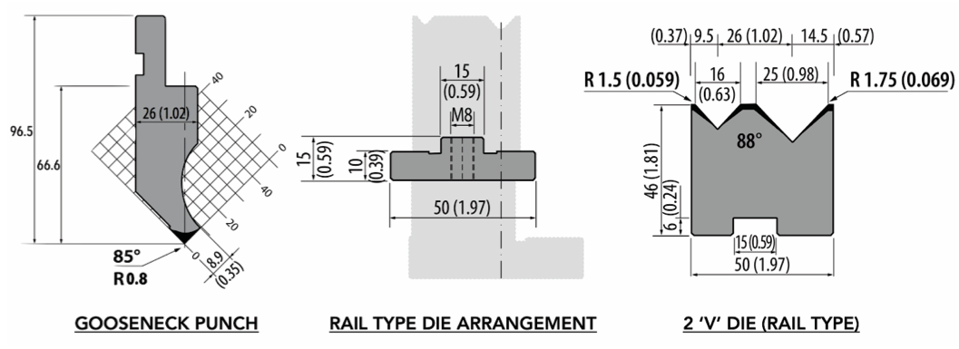
STANDARD EQUIPMENTS OF THE MACHINE
- JAPANESE DESIGN THREE BEAM DESIGN HYDRAULIC ANTI DEFLECTION SYSTEM IN LOWER BEAM.
- QUICK RELEASE PUNCH ADAPTORS
- DIE RAIL CLAMPING ELEMENTS.
- FRONT SHEET SUPPORTERS WITH ECCENTRIC STOPS - 2 UNITS (OPTIONAL).
- MOTOR OVERLOAD PROTECTION RELAY (SAFETY EQUIPMENT).
- CNC SERVO MOTOR CONTROLLED BACK GAUGE ‘X’ AXIS.
  - CONTROLLED WITH SERVO MOTOR (LEAST COUNT BEING 0.1MM)
  - MOUNTED ON LINEAR GUIDE WAYS (L.M. RAILS).
  - DRIVEN WITH ROLLED C7 CLASS BALL SCREWS.
- SET OF FLIPPERS WITH THE BACK GAUGE- 2 UNITS.

  - BACK GAUGE ‘R’ AXIS WITH MANUAL MOVEMENT HANDLE TYPE
  - BACK GAUGE ‘Z’ AXIS MOUNTED ON LINEAR GUIDE WAYS (L.M. RAILS).
  - FINE TUNING KNOB FOR CALIBRATING THE FINGERS.

PLEASE REFER THE BROCHURE FOR IMAGES OF THESE EQUIPMENTS.

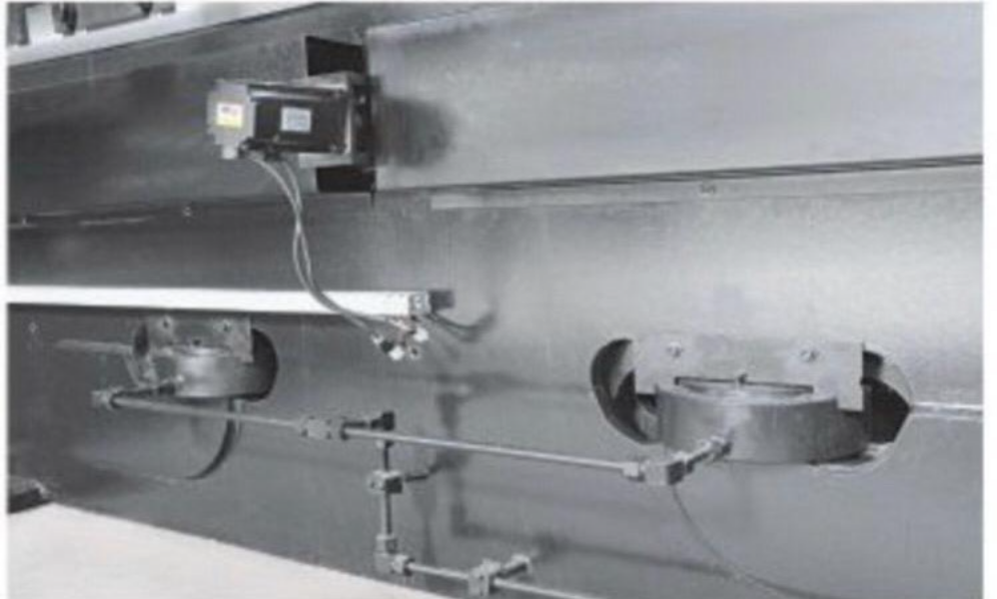

SPECIFICATIONS AND FEATURES OF CNC CONTROLLER
MODEL: CYBELEC - CYBTOUCH 8PS CNC CONTROLLER; SWITZERLAND
- 8” toucH SCREEN COLOUR DISPLAY WITH Simple pages, clear display AND large keys.
- Intuitive and userfriendly interface.
- Easy single bends with the EasyBend page.
- Easy manual movement.
- 2D graphic profile creation with manual sequencing (optional).
- Bend allowance calculation.
- Pressure – crowning calculation.
- BENDING Angle and back gauge correction.
- MEMORY: 10 MATERIALS. 24 STEPS. 300 PROGRAMMES; 100 PUNCH; 100 DIES

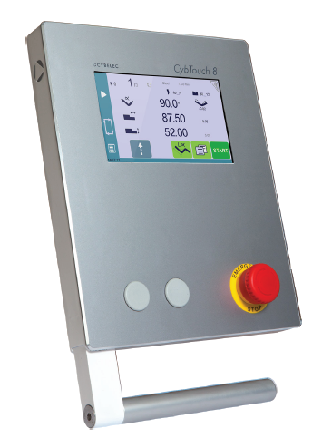

SPECIFICATIONS FOR THE HYDRAULIC PRESS BRAKE MACHINE WITH 2000 M.M. WIDTH AND 4 M.M. THICKNES.
1. CNC SYNCHRO PRESS BRAKE CAPACITY 125 TON SIZE 2000 x 4 MM WITH CNC CONTROLLED BACK GAUGE & CYBELEC CYBTOUCH-8P (SWISS) MAKE CONTROLLER, BALL SCREW, A.C. SERVO MOTOR, ENCODER & ELECTRICALS BUT WITHOUT HYDRAULIC OIL AND AS PER FOLLOWING SPECIFICATIONS:

TECHNICAL SPECIFICATIONS

BENDING CAPACITY (L x T) |  | 2000 X 4 MM (MS)
TONNAGE |  | 125 TON
CLEAR DISTANCE BETWEEN HOUSING (MM) |  | 2200 MM
RAM STROKE (MM) |  | 200 MM
OPEN HEIGHT (MM) |  | 400 MM
CLOSED HEIGHT (MM) |  | 200 MM
RAM SPEED (APPROXIMATED)
 | APPROACH (MM/SEC) | 70
 | PRESSING (MM/SEC) | 8
 | RETURN (MM/SEC) | 50
ELECTRIC MOTOR (H.P.) |  | 30 H.P.
X AXIS TRAVEL (AUTOMATIC CNC) (APP.) |  | 700 MM
R AXIS TRAVEL |  | 100 MM
TOTAL UNITS OF FLIPPER |  | 2 UNITS
QUICK CHANGING CLAMPS |  | 30 UNITS
FULL LENGTH OF GOOSENECK PUNCH |  | 1 UNIT
FULL LENGTH OF 2 -‘V’ DIE |  | 1 UNIT
FULL LENGTH OF DIE RAIL |  | 1 UNIT
HYDRAULIC CROWNING CYLINDER |  | 4 UNITS

PRICE DETAILS

PRICE OF THE MACHINE WITH CNC CONTROLLED
R – AXIS & CYBELEC CONTROLLER, BACKGAUGE,
BALL SCREW, A.C. SERVO MOTOR, CNC HYDRAULIC
CROWNING, WITH ENCODER & ELECTRICALS
BUT WITHOUT HYDRAULIC OIL
INCLUDING ONE SET OF TOOLING
• 2 – V DIE WITH RAIL & BASE
• SEMI GOOSE NECK PUNCH : Rs.26,00,0000/-

(RUPEES Twenty-Six Lakhs Only)

GENERAL TERMS & CONDITIONS:

- Price quoted per unit ex-work. Hyderabad.
- Following charges are additional to your account.
- Freight Charge : As actual to be borne by you.
- Tax : as applicable
- Packing charge : As actual to be borne by you.
- Insurance : As actual to be borne by you.
- Payment : 50% advance along with order another 25%
advance after 3 weeks from first advance and
balance before delivery but after inspection at our
works.
- Delivery : 8-10 weeks from date of techno-commercially clear
purchase order.
- Validity : One month from the date of submission.
- Inspection : Inspection at our works prior to dispatch.
- Warranty : The cylinder is warranted for a period of 12
months from the date of dispatch against any
manufacturing defects/faulty material or bad
workmanship of any part or component but not
against any kind of abnormal or improper use of
machine. Defective part or component will be
replaced or repaired free of cost. Electrical
components are outside the scope of this
warranty.
- Commissioning : Erection & commissioning done by you, but if
required technical support & guidance provide by
us at additional cost.

NOTE:
- Hyd. Oil is not in scope of our supply.
- Raw material for trial is arrange by you at your cost.

We are sure you will find our offer in line with your requirements. Should you require any further clarification please call us on mobile number
(+91) - 9246221106/ +91- 9849207176

Thanking you and assuring you of our best services.

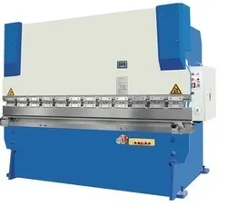

For TECHNO MACHINE TOOLS

T. SIVARAMAKRISHNA

